一、东北三省为主的春大豆区
二、黄淮流域的夏大豆区
三、长江流域的春、夏大豆区
四、江南各省南部的秋作大豆区
五、两广、云南南部的大豆多熟区
其中，东北春播大豆和黄淮海夏播大豆是我国大豆种植面积最大、产量最高的两个地区
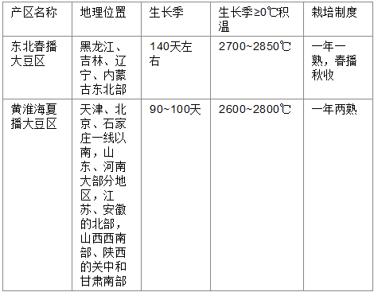

{{633 Wrather,J.A. 2006;}}, {{918 Wrather,J.A. 2001;}}
Soybean cyst nametode is the most destructive disease for soybean in United States.
"144 Wu,Xiaolei 2009"里说是这两篇文章说道了1.5bilion USD loss. 但是我在里面没找到。
{{1291 Anand,S.C. 1991;}}

a wild type soybean with new resistance: PI 468916, a wild soybean (Glycine soja)

{{2924 Zheng,J. 2006;}}
Chen's work, mentioned that virulence will change due to the use of resistant cultivar.
Zheng mentioned that increase of virulence on PI88788 has occurred in filed experimental plot after 8 years of continuously planting the same resistant cultivar Freeborn ( PI 88788 resistant source)
J.P. Ross and C.A.Brim, 1957
没什么有价值的内容。并没提到抗性基因的数量。

{{137 Caldwell,B.E. 1960; }}
首次提出三个recessive 的抗病基因，命名为rhg1, rhg2, rhg3。抗性标准： 根部有一个或一个一下雌线虫，抗病。根部有一个以上雌线虫，感病。
没区分线虫的种，只是随便选了三个线虫population
All F2 of Peking PI90763
All F2 of Peking PI84751,
说明它们有同样的3个loci.

{{138 Matson,Arnold L. 1965; }}
提出有四个基因。rhg 4 是dominant的。根本没交代抗性标准是什么。

{{141 HARTWIG, E. E., and J. M. EPPS. 1970; }}
只有一段话，说是在某地方发现的有一个线虫population，peking susceptible, PI90763 resistant. 又说经过遗传学实验证明，有另外一个隐性基因控制对线虫的抗性。 但对遗传实验具体怎么做根本没提。 这难道就是rhg 5的来源？？？？

{{194 Golden AM, Epps JM, Riggs RD, Duclos LA, Fox JA, Bernard RL 1970; } }
纸质版的文献。
根据年代早晚列了4个race,并用4个identification line 把这四个race 区分开了。标准就是reproduction 小于10% on lee, 就算resistant. 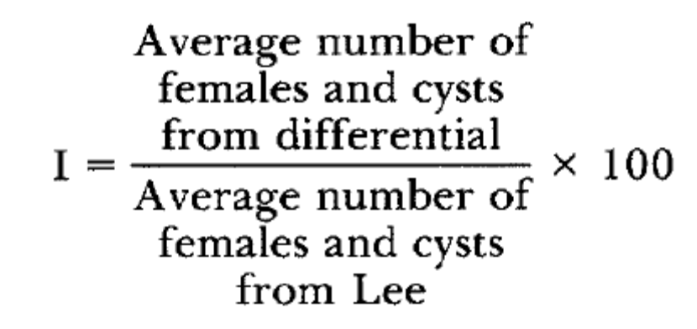
他这里的4个race 跟后期列出的16 race 的表格中的race1-4 完全一致。

{{45 Thomas,J.D. 1975; }}
提出race 4 的抗性是由one dominant and two recessive 决定的。 但是抗性标准却和通用的不同。而且他在abstract中还提到还有两个additional 基因are necessary for race 4. 但我没看到他在正文其他地方提到这件事。
抗性标准：
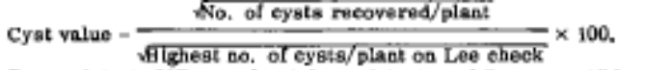
把抗性分为
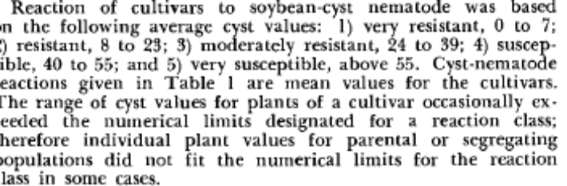

{{6 Concibido,Vergel Cierte 1995; }}

Nevin young 1995 年PHD 的 mapping resistance gene 博士论文。内容很多，跟我做的很像，只是marker不同。

{{116 Anand, S. C. 1996; }} 这个的抗性标准是通用的标准
Resistance to race 3 有两个基因控制,一个dnominant, 一个recessive. bbCC
Resistance to race 5 有四个基因控制， 一个 dnominant, 3个 recessive. aabbCCdd.
dd 对cc 有epistasis的作用。A,B,C 三个locus 必须全部处于抗性状态才表现出抗性，即susceptible的基因对其他locus的抗性基因型有 epistasis作用。

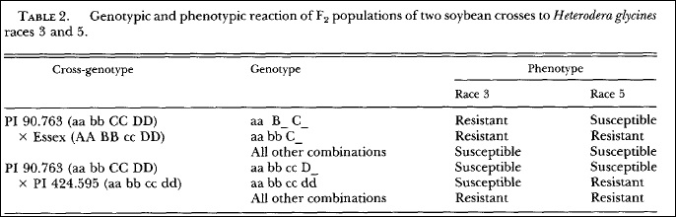

{{5 Rao Arelli, A.P. 1997; }}

Race 1 and race 2 were cultured for 24 and 31 generations to get near homogenous lines.
In their abstract, they mentioned to data, there are 118 resistant accessions are identified, and these are primarily resistant to races 3, 5, 14.

They tested total 86 accessions with known resistance to race 3, 5 or 14 for reaction to isolates of races 1 and 2.
PI lines resistant to race 1 or race 2
 | MG | Seed color | Race1 | Race 2
PI84751 | IV | black | 3 | 50
PI89772 | IV | Black | 2 | 7
PI90763 | IV | black | 1 | 3
PI303652 | V | black | 2 | 84
PI339868-B | IV | black | 2 | 35
PI404166 | III | black | 1 | 10
PI404198-A | IV | black | 1 | 9
PI404198-B | IV | black | 2 | 79
还有很多，略
抗race 2 的
 | MG | Seed color | Race1 | Race 2
PI90763 | IV | black | 1 | 3
PI404166 | III | black | 1 | 10
PI404198-A | IV | black | 1 | 9
PI437654 | III | black | 0 | 2
PI48489-B | IV | black | 0 | 7
PI567432 | V | green | 20 | 8
PI567491A | III | black | 0 | 11
PI437690 | III | black | 1 | 13
PI567516C | IV | yellow | 9 | 13

(P. R. Arelli, Sleper, Yue Pin, & Wilcox, 2000)
列了许多PI resistant to race 1 and 2

{{196 R.D.RIGGS AND D.P.SCHMITT 1988; }}
提出16 race 的 open form.

{{140 Triantaphyllou, A.C. 1975; }}

{{42 Riggs,R.D. 1988; }} 是一篇挺好的review.

Webb,1997 US006162967A positional cloning
根本没clone rhg1， 只是注册了marker的专利，叫别人怎么clone。

(Concibido, Diers, & Arelli, 2004) 综述： 列举了1992 年以后到2004年所有 SCN mapping 的16偏文章

Webb 2003 US patent 6538 175B1.
inbred line 作为mapping population.

Linkage and mapping distance: MAPMAKER/EX(3.0) . scan for QTL by single locus: Mapmaker/QTL (Landry 1991). LOD of 3.0 to declare linkage of a marker with QTL (Lander 1989)
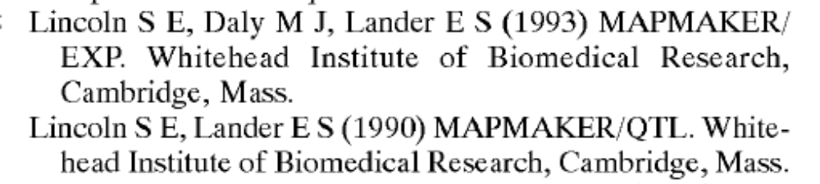
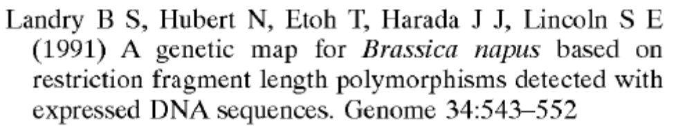
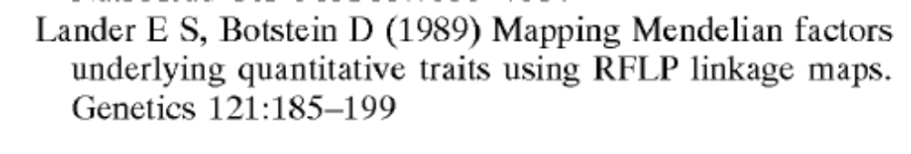

(D. M. Webb et al., 1995)

Genetic-Mapping of Soybean Cyst-Nematode Race-3 Resistance Loci in the Soybean Pi-437.654
Mapping population: F6:7 RIL.

(A. P. R. Arelli & Webb, 1996)
(D. M. Webb, 2000)

{{2478 Raoarelli,A.P. 1994;}}
Maker select
{{143 Li,Ying-Hui 2009;}}
直接haplotype analysis 来找抗SCN的SNP marker.
{{1653 Iqbal,M.J. 2009;}}
Rfs2/rhg1 locus 范围内一个diphenol oxidase gene is cloned and analyzed for its function to confer resistance to SDS and SCN.
{{144 Wu,Xiaolei 2009;}}
2009 | QTL, additive and epistatic effects for SCN resistance in PI 437654
用了F7:9 RIL 做的mapping.
{{50 Winter,Shawn M.J. 2007;}}
QTL associated with horizontal resistance to soybean cyst nematode in Glycine soja PI464925B
Mapping population : F (4:5) recombinant inbred line (RIL) population

{{1855 Ferdous,S.A. 2006;}}
QTL analysis of resistance to soybean cyst nematode race 3 in soybean cultivar toyomusume
Mapping population: 115 recombinant inbred lines (RILs)

{{161 Guo,B. 2006;}}

Identification of QTLs associated with resistance to soybean cyst nematode races 2, 3 and 5 in soybean PI 90763
Mapping population: 220 F2:3 family, 2 replications, 5 individuals per family. 用了1000 SSR markers.

没给出 margin of error

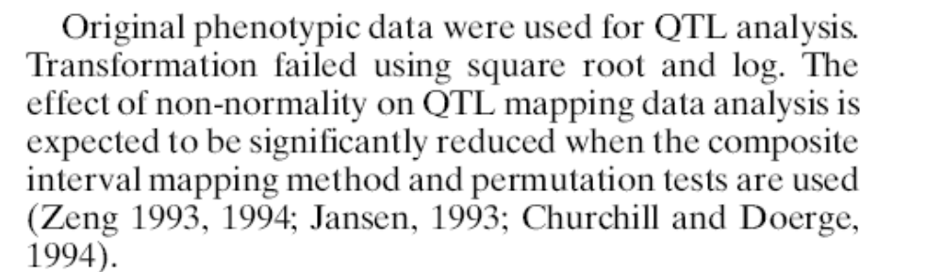

Multiple interval mapping
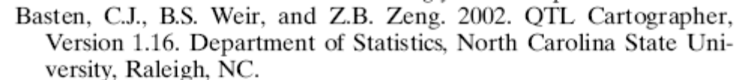

{{299 Guo,B. 2006;}}
QTLs associated with resistance to soybean cyst nematode in soybean meta-analysis of QTL locations-retraction
没找到，好像是被retracted了。
{{1861 Guo,B. 2006;}}
Quantitative trait loci underlying resistance to three soybean cyst nematode populations in soybean PI 404198A
F2:3 family, 5 individuals per family,2 replications
{{305 Kassem,M.A. 2006;}}
An updated 'Essex' by 'Forrest' linkage map and first composite interval map of QTL underlying six soybean traits
Mapping population: RIL
{{163 Guo,B. 2005;}}
Identification of QTLs associated with resistance to soybean cyst nematode races 2, 3 and 5 in soybean PI 90763
Mapping population: F2:3 family
{{339 Kopisch-Obuch,F.J. 2005;}}
Association between soybean cyst nematode resistance loci and yield in soybean.
没做mapping,只是介绍了一些NIL line, 然后看看SCN抗性和yield的关系
{{191 (Vierling, Faghihi et al. 1996).A. 1996;}}
Association of RFLP markers with loci conferring broad-based resistance to the soybean cyst nematode (Heterodera glycines)
200 F2:3 family, 4 replications per family.
{{34 Faghihi,J. 1995;}}
Resistance genes in 'Williams 82' x 'Hartwig' soybean cross to an inbred line of Heterodera glycines
不是mapping，是做遗传学试验看看有那些resistant gene. F3 phenotyping 用了4个重复。

{{126 Weisemann, J. M. 1992;}}
1992 | Molecular markers located proximal to the soybean cyst nematode resistance gene, Rhg 4.
没做SCN assay. 用seed color 来代替SCN resistance.
{{1063 Chang,S.J.C. 1997;}}
Association of loci underlying field resistance to soybean sudden death syndrome (SDS) and cyst nematode (SCN) race 3
Mapping population: F5:11 RIL.
{{1162 Mahalingam,R. 1995;}}
DNA markers for resistance to Heterodera glycines .1. Race 3 in soybean cultivar Peking
Mapping population. F2:3 family. 10 F3 plants per family were tested.
{{898 Meksem,K. 2001;}}
Mapping population RIL
{{19 Heer J.A. 1998;}}
Molecular markers for resistance to Heterodera glycines in advanced soybean germplasm.
F2:3 family. 10 F3 plants per family.
{{1187 Concibido,V.C. 1994;}}
Dna Marker Analysis of Loci Underlying Resistance to Soybean Cyst-Nematode (Heterodera-Glycines Ichinohe)

F2:3 family, 25 plants per family were tested using two different methods.
{{185 Qiu,B.X. 1999;}}
RFLP markers associated with soybean cyst nematode resistance and seed composition in a 'Peking' x 'Essex' population
F2:3 family. 5 individual are tested for SCN resistance in each family.

{{20 Wang,D. 2001;}}
5 F2:4 plants in each F2:4 families were tested. There are only 57 F2:4 families.
{{177 Schuster,I. 2001;}}
居然用了一个叫做BC3F2:3的population. 183个F2 以及 6个individual of each F2:3 family were tested for SCN. F2 是先测完，把跟洗干净，再种上生出F3.

{{1113 Concibido,V.C. 1996;}}
RFLP mapping and marker-assisted selection of soybean cyst nematode resistance in PI 209332

F2:3 and F5:6 for mapping population.
10 plants in each family is tested for SCN. 他给出的平均值有margin of error
{{114 Concibido, V. C. 1997;}}
Genome mapping of soybean cyst nematode resistance genes in 'Peking', PI 90763, and PI 88788 using DNA markers.
F2:3 family. 12 individuals per family is tested.

QTL statistic theory:

{{2920 Cowen,N.M. 1988;}} 讲了QTP mapping 不同progeny的构建以及他们LSD的算法
{{2921 Darvasi,A. 1997;}} 讲了确定marker location 的 power
{{2923 Knapp,S.J. 1990;}} 要好好看看
{{2922 Zhang,Y.M. 2004;}}

References
Arelli, P. R., Sleper, D. A., Yue Pin, & Wilcox, J. A. (2000). Soybean reaction to races 1 and 2 of heterodera glycines. Crop Science, 40(3), 824-826.
Arelli, A. P. R., & Webb, D. M. (1996). Molecular genetic diversity among soybean plant introductions with resistance to heterodera glycines. Current Science, 71(3), 230-233.
Concibido, V. C., Diers, B. W., & Arelli, P. R. (2004). A decade of QTL mapping for cyst nematode resistance in soybean. Crop Science, 44(4), 1121-1131.
Webb, D. M., Baltazar, B. M., Raoarelli, A. P., Schupp, J., Clayton, K., Keim, P., et al. (1995). Genetic-mapping of soybean cyst-nematode race-3 resistance loci in the soybean pi-437.654. Theoretical and Applied Genetics, 91(4), 574-581.
Webb, D. M. (2000). In Pioneer Hi-Bred International I. (Ed.), Positional cloning of soybean cyst nematode resistance genes (800-312 ed.). USA; USA:
Yue, P., Arelli, P. R., & Sleper, D. A. (2001). Molecular characterization of resistance to heterodera glycines in soybean PI438489B. Theoretical and Applied Genetics, 102(6-7), 921-928.
Yue, P., Sleper, D. A., & Arelli, P. R. (2001). Mapping resistance to multiple races of heterodera glycines in soybean PI 89772. Crop Science, 41(5), 1589-1595.

Heer, J. A., H. T. Knap, et al. (1998). "Molecular markers for resistance to Heterodera glycines in advanced soybean germplasm." (Journal Article).
Vierling, R. A., J. Faghihi, et al. (1996). "Association of RFLP markers with loci conferring broad-based resistance to the soybean cyst nematode (Heterodera glycines)." Theoretical and Applied Genetics 92(1): 83-86.

